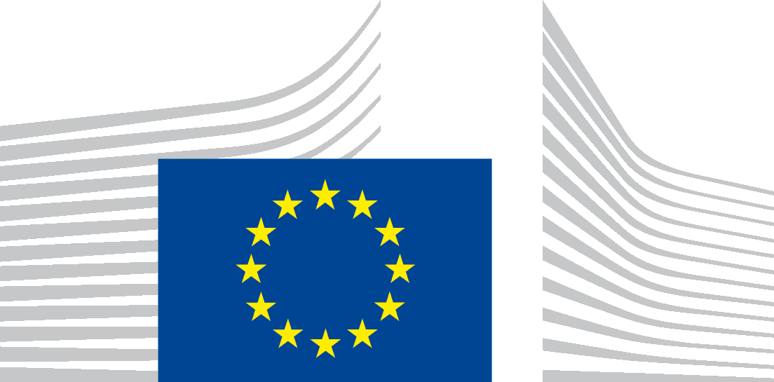 | EUROPEAN COMMISSION  DIRECTORATE-GENERAL for employment, social affairs and inclusion  Directorate E Labour Mobility and International Affairs  Unit E1 Labour Mobility, Public Employment Services, ELA

Accessibility statement for Europass
This statement applies to content published on the domain: https://europa.eu/europass and any of its subdomains.
This website is managed by DG EMPL, Unit E1. It is designed to be used by as many people as possible, including people with disabilities.
You should be able to:
- Zoom up to 200% without problems.
- navigate most of the website using just a keyboard
- navigate most of the website using a modern screen reader and speech recognition software (on your computer or phone)]
This website is designed to comply with the technical standard for websites and mobile apps, EN 301 549, v.3.2.1. This closely follows level ‘AA’ of the Web Content Accessibility Guidelines (WCAG) version 2.1.

Compliance status
This website is partially compliant with technical standard EN 301 549 v.3.2.1 and the Web Content Accessibility Guidelines (WCAG) 2.1 Level AA. See ‘Non-accessible content’ for more details.
The website was last tested in April 2023

Preparation of this statement
This statement was reviewed on 15.12.2023.

Feedback
We welcome your feedback on the accessibility of the Europass website. Please let us know if you encounter accessibility barriers:
- Phone: 00 800 6 7 8 9 10 11 from anywhere in the EU weekdays 09:00 - 18:00 CET in any EU language* (calls are free).
- Feedback form: Write to us via the Europass contact form
We try to respond to feedback within 15 business days from the date of receipt of the enquiry by the responsible Commission department.

Compatibility with browsers and assistive technology
The Europass website is designed to be compatible with the following most used assistive technologies:
- the latest version of Google Chrome, Mozilla Firefox and Microsoft Edge browsers;
- in combination with the latest versions of assistive technologies.

Technical specifications

The accessibility of the Europass website relies on the following technologies to work with the particular combination of web browser and any assistive technologies or plugins installed on your computer:
- HTML
- WAI-ARIA
- CSS
- JavaScript

Non-accessible content
While we are committed to ensuring the accessibility of the Europass website, there are known limitations that we are actively addressing. We appreciate your understanding and patience as we work towards resolving these issues. If you encounter an accessibility challenge not listed below, please contact us.
Known Limitations (Scheduled for Resolution by the End of 2024:
- Some pages may have poor colour contrast.
- Some functionalities are not accessible or have limited accessibility (low focus) for users who use only keyboard.
- Most visuals do not have alt text descriptions in the corresponding language.
- Some fields do not have labels for screen readers or similar assistive technologies.
- Some error messages are not clearly associated with form controls.
- Some documents are in PDF format and are not accessible.
- Some pages are not fully adapted for screen readers or similar assistive technologies.
- Some headings are not structured correctly for assistive technologies.
- Some pages have content elements such as tables and side menus that may not be accessible.
- Some URLs do not have understandable or correct path names.
- Some elements are not entirely adapted to mobile accessibility.

